**Organ Segmentation and Labeling in MRI Images**

**Problem Statement**

Due to increase in a large dataset of human body MRI, it is tedious and time-consuming to segment each organ manually and then automatically analyze patient-specific organ. To make the process digitized computerized analysis of these images requires accurate segmentation of anatomical regions. The segmented images contain homogeneous, non-overlapping, semantically meaningful regions of the similar attribute. Classification is used to label each segmented organ. Intensity-based image segmentation is feasible when there is a large difference between the intensities of the object of interest and its background. In spatial interaction model, each intensity is dependent on a subset of neighboring intensities. The local spatial interaction can be caught by MRF (Markov Random Field) model.

**Background**

It is not an easy task to automatically segment MRI because MRI is imperfect or corrupted by noise and other image artifacts. Segmentation results are affected by:

* Inhomogeneous artifacts: that cause shading when simple gray level based segmentation is used.
* Partial volume effect: when a single pixel is covered by multiple tissues then different object boundaries become blurred.

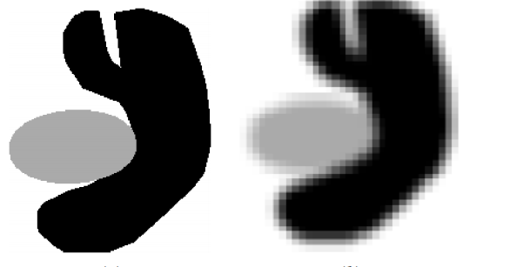

Fig 1. Partial Volume Effect [1]

Intensity-based pixel classification methods have both effects.

The segmentation categorized as Region-based, threshold based, atlas-based, cluster-based, classifier based and model-based. The model-based techniques include Markov Random Field (MRF), Neural Network, Deformable model. The threshold-based method does not consider spatial characteristics and sensitive to noise. In region-based segmentation due to partial volume affect the separated regions might be connected. A classifier-based technique like k-nearest neighbor, Parzen, Expectation Maximization require training data and clustering method require initial parameters. MRF requires an algorithm that is computationally intensive. ANN is good but reduces potential computation due to the serial computer. Deformable models are robust towards the noise and spurious edges, however, exhibit poor convergence towards concave boundaries.

Some researchers used the atlas-based technique for organ segmentation. The limitation of the atlas-based technique is that it is difficult to compute deformation field between regions and misses fine structural details. So rather than scanning complete image. The image is divided into patches. However, patch-based approach impacts the performance of the predictive model. Some other researchers provide classification forest-based method for organ segmentation. It has good generalization property and automatically selects right feature for the task but it suffers from noisy predictions.

There are two segmentation schemes. In hard segmentation, a pixel is not allowed to belong to different regions. While in soft segmentation a pixel is allowed to belong to different regions with varying degree of membership. Soft segmentation can be done using fuzzy logic while hard segmentation can be produced by k-mean.

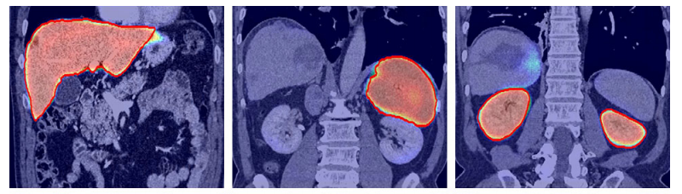

Fig 2. Organ Segmentation [2]

**Methodology**

Since CNN (convolutional Neural Network) are capable of learning complex and non-linear structure. In that output of each layer is feed as input to the next layer and the final output is a feature map. These can be used for segmentation of organs. Training the network on different organs and extracting their features and then using those feature for extraction of an organ segment.

**Stage 1 Data collection:**

In this stage different organ MRIs will be collected and labeled. It involves the collection of MRI of Kidney, Lung, Liver, Gallbladder, Pancreas, Spleen, Stomach

**Stage 2 Data Pre-processing:**

In this stage, all images will be processed for removing noise, intensity normalization, bias-field correction.

**Stage 3 Constructing model:**

In this stage, some pre-trained models like ResNet will be explored on MRI images.

**Stage 4 Training and Experimentation:**

In this stage, the pre-processed images will be feed as input to the network. After training, the network will be tested on other MRI images for segmentation.

Training

on

MRIs of different organs

Pre-processing

Orientation

Bias-Field Correction

Intensity Normalization

Background noise removal

Training CNN

Model

Input MRI

Segmented MRI

Fig 3. Organ Segmentation using CNN

**Experimental Design**

**Evaluation Measures**

Measures such as Precision, Recall, True Positive rate, root mean square surface rate can be used.

**Dataset**

MRI from the VISCERAL Anatomy organ segmentation dataset,

MIDAS (NAMIC) dataset,

<http://www.mr-tip.com/serv1.php?type=db1&dbs=Abdominal%20Imaging>,

[http://sliver07.org/index.php](https://www.researchgate.net/deref/http%3A%2F%2Fsliver07.org%2Findex.php),

Open access medical repositories

MRIs of patients from hospitals

**Software and Hardware Requirements**

The project will be implemented and experimented using anaconda python libraries.

**Software:**

* Anaconda
* Python
* Tensorflow
* keras
* Matplotlib

**Hardware:**

Training will be conducted on NVIDIA GPU

**References**

1. Pham, Dzung L., Chenyang Xu, and Jerry L. Prince. "Current methods in medical image segmentation." Annual review of biomedical engineering 2.1 (2000): 315-337
2. Peijun Hu · Fa Wu et.al., “Automatic abdominal multi-organ segmentation using deep convolutional neural network and time-implicit level sets”, Int. JCARS, Springer DOI 10.1007/s11548-016-1501-5
3. Neeraj Sharma and Lalit M. Aggarwal, “Automated medical image segmentation techniques”, J Med Phys. 2010 Jan-Mar; 35(1): 3–14, doi: 10.4103/0971-6203.58777
4. Pham, Dzung L., Chenyang Xu, and Jerry L. Prince. "Current methods in medical image segmentation." Annual review of biomedical engineering 2.1 (2000): 315-337